Marr College
Frequently Asked Questions for New Pupils

We hope that the following information is helpful to you. Further information about the school can be found on the Marr College website www.marr.sayr.sch.uk.

SCHOOL DAY
The start, finish and period times are shown below.

Monday and Tuesday |  |  | Wednesday, Thursday, Friday
Personal Support | 8.45 – 8.55 |  | Personal Support | 8.45 – 8.55
Period 1 | 8.55 – 9.45 |  | Period 1 | 8.55 – 9.45
Period 2 | 9.45 – 10.35 |  | Period 2 | 9.45 – 10.35
Interval | 10.35 – 10.50 |  | Interval | 10.35 – 10.50
Period 3 | 10.50 – 11.40 |  | Period 3 | 10.50 – 11.40
Period 4 | 11.40 – 12.30 |  | Period 4 | 11.40 – 12.30
Period 5 | 12.30 – 1.20 |  | Lunch | 12.30 – 1.10
Lunch | 1.20 – 2.00 |  | Period 5 | 1.10 – 2.00
Period 6 | 2.00 – 2.50 |  | Period 6 | 2.00 – 2.50
Period 7 | 2.50 – 3.40

THE SCHOOL BUILDING
When pupils start in S1, they will have S6 buddies who will help them during their first couple of weeks by taking them to classes, showing them canteen and other areas of the school. S1 pupils will also be given a map of the school to help them find their way about. Guidance staff and Personal Support teachers will also be able to help pupils settle in to the school.
Pupils who join throughout the year will be allocated a buddy in their class to help them find their way around and settle in.

UNIFORM
All students are expected to wear trousers/skirt, shirt, tie and appropriate black footwear. It is possible to order a Blazer from Ayrshire Schoolwear in Kilmarnock (01563 550200) or alternatively our Parent Council manage a Blazer shop/exchange via their Facebook page.
Hooded tops can be worn but must be removed when in classes.
The following clothing is NOT allowed:
- potentially, encourage friction (such as football colours);
- could cause offence (such as anti-religious symbolism or political slogans);
- could cause health and safety difficulties, such as loose-fitting clothing, dangling earrings, are made from flammable material, in practical classes;
- carry advertising, particularly for alcohol or tobacco; and could be used to inflict damage on other pupils or be used by others to do so.

PE KIT
W have a formal PE kit that we expect all students to wear. This will consist of Marr College PE top and black shorts or sports leggings. We believe that if all students are wearing the same kit this will give them a greater sense of identification to Marr College, inspire a feeling of togetherness and create a more professional learning environment.
Orders can be made via an online shop on our supplier’s website. Instructions on how to access the online shop are below:
- Go to www.pslteamsports.com
- Navigate to the Education drop down menu on the home page.
- Select Marr College
On this page you will be able to order your child's PE top and other items of kit. Prices, specifications and sizes are listed for each item.
CLASSES
All pupils attend Personal Support first every morning. This is a 10-minute period where they will receive relevant information about things going on in the school/ opportunities for trips etc. They may also be handed out report cards and other forms/ information during Personal Support.

In S1 & S2, pupils will have a wide range of Broad General Education subjects which they will attend either with their register class (e.g. 1D, 1F) or as a practical class (e.g. 1p1, 1p5 etc.). Each pupil will be issued with their own timetable at the start of the year which they will follow throughout the session. An example of an S1 timetable is shown below.
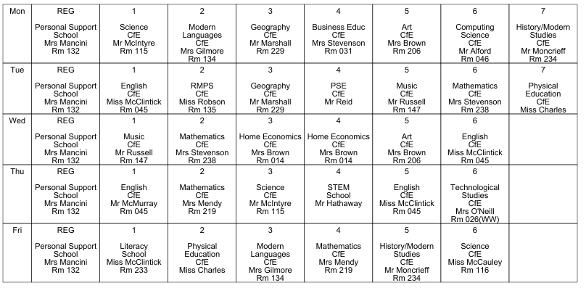

SCHOOL MEALS
In Marr College students have the opportunity to purchase food at the start of the school day, at interval and at lunchtime. Lunches can also be pre-ordered by 10am via the Vericool app.
No cash is accepted in school – money for meals must be added via the pupil’s account on ParentPay, our online school payments system.
There are also spaces for pupils to eat packed lunches in school.
If a pupil is entitled to a free school meal, an application for this must be submitted each session (see below)
S1 students are not allowed out of the school grounds at interval or lunchtime.

Free School Meals and Clothing Grant
Information on eligibility criteria etc. and the application form for the above can be found on the South Ayrshire Council website at https://beta.south-ayrshire.gov.uk/free-school-meals
If you need help to claim please call 0300 123 0900 to speak to one of the council customer service advisors.

TRANSPORT
Information on eligibility criteria etc. and the application form for free school transport can be found on the South Ayrshire Council website at https://beta.south-ayrshire.gov.uk/article/28205/Free-school-transport
If you do not have access to complete this form online you can obtain an application form by contacting Educational Services on 01292 612284 or by email at SACSchoolTransport@south-ayrshire.gov.uk to get a blank application form sent to you.

LOCKERS
All students have access to a locker (accessed via a personal key code) at the start and end of day as well as at interval and lunchtime. Individual locker details are issued to all pupils when they start at Marr College and they keep this locker throughout their time here.

HOUSE GROUPS
There are 5 House groups at Marr College – pupils will be allocated to a house when they start at Marr College. This will also be their register class (Year group, House e.g. 1L, 2D).

Each house group has a Principal Teacher of Guidance in charge along with a Depute Head Teacher who is Head of House.

The Guidance teacher is the first point of contact if pupils have any issues in school.

The current staff are as follows.

Guidance Teacher Year Head
Fullarton Mr Bell Mrs Anderson
Lothian Mr Higgins Mr Ward
Portland Mr Reid Ms McCallum
Welbeck Mrs Levif W & W1
Mr Harris W2 Mr Hobson
Darley Mrs Cooper S1,2,5 & 6
Mr Connell S3 & 4 Mr McLean

SUBJECT CHOICES
In February/ March, pupils in S2 – S5 choose the subjects they would like to study in the following year. The number of subjects and levels they choose depends on what year group they will be going in to.
S3 pupils still follow the Broad General Education so have a range of subjects. In S4 – 6, pupils work towards their SQA qualifications – National 4, National 5, Higher and Advanced Higher. Information on the options process and subject choices can be found on the Marr College website http://www.marr.sayr.sch.uk/course-options.html

Further information is issued to pupils before they need to make their choices and they will have a 1-1 meeting with their Guidance Teacher before finalising their options.

EXTRACURRICULAR ACTIVITIES
There are various clubs and activities which pupils can join. These will be advertised via information at Personal Support, information from class teachers involved in the activities, posters around the school, PE department (for sports clubs). Some of the current activities/ clubs include:

Art Club, Athletics, Badminton, Basketball, Computer Club, Chess Club, Debating, Football, Golf, Hockey, Netball, Rugby, Science Club, Volleyball, Reading Ambassadors, STEM club.

There are music instructors who visit the school to give music lessons. Further information can be obtained from the music department.

CONTACTING THE SCHOOL
The school phone number is 01292 690022
School email address is marr.mail@south-ayrshire.gov.uk
You can also message the school via the Groupcall Xpressions app which can be downloaded on any Android or Apple device.

ABSENCES
Any absences should be notified to the school office via phone, email or xpressions app as soon as possible on the morning of the absence.

Absence text messages will be sent out to parents around 9.40am for any pupils marked absent in class. Please reply to this text or phone the school with the reason for absence.

Dental and medical appointments should be made outwith school time where possible. However we understand that this is not always possible. If a pupil needs to be absent from school for an appointment, you should inform the school in advance of the appointment detailing the time pupil needs to leave and approximate time they will return to school.

CORRESPONDENCE FROM THE SCHOOL
Information from the school, including letters, updates on events etc. will be sent out via our Groupcall system. This will be either by text, email or xpressions app. It is important that we have up to date contact details in order that these messages are received by you.

Progress reports are issued to pupils at certain times of the year. The dates for each year group can be found on the school calendar which is on the school website.
Parents’ evening details are also detailed on the school calendar.

PARENTS’ EVENINGS
The dates for these are on the school calendar each year which is available on the school website and will also be emailed out to parents at the start of the school year.
Appointments are made via our online booking system – information is sent out prior to the parents’ evening on how to access this and make appointments.

MEDICATION
If pupils require to take mediation during the school day, the appropriate form should be obtained from the school office, completed by parent/ carer and returned along with the medication - which should be clearly marked with the pupil’s name. The medication will be stored securely in the school office for the pupil to access when required.
In some cases a care plan will also need to be completed - you should contact the school office or Guidance teacher for more advice if required.

SCHOOL POLICIES
The school policies can be found on the school website.
School Policies (marr.sayr.sch.uk)

PARENT COUNCIL
The Parent Council is open for any parents with a child at Marr College. Meetings are held monthly and all parents are welcome to attend – you do not need to be a member of the Parent Council to attend the meetings. Information is on the school calendar and reminders are messaged out before each meeting.
The parent council can be contacted via email
marrparentcouncil@gmail.com

